iCar

By: Mohammad-Ali Bandzar, Braulio Carrion & Matthew Cotton

TEJ4M –– Mr. Wong

1/17/19

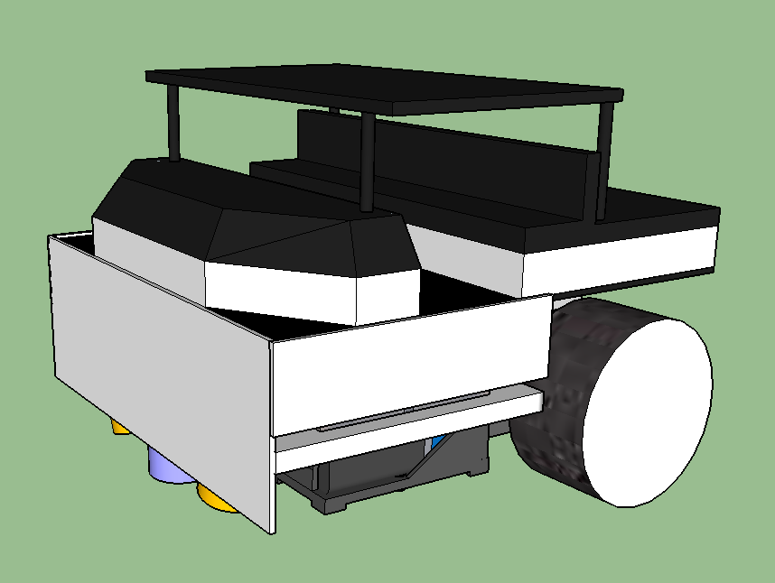

**Table of Contents**

*Chapter* *Page*

Table of Contents .…….....……………………….………………………...1 Introduction ……………………………………………….…..…………….2 Master Schedule …………..………………………………………………...3 GANTT Chart ……...……...…………………….…………………...……..4 Planning Organizer ……………..………….……………………………….5 PERT Chart ……………...……….……………...…………….…………….6 Evaluation …………………………………………………………………...7

**Introduction**  
 The goal of this project is to build an Intelligent Car that will be able to follow a black line on a flat surface. The reason we created the iCar is so it travels through a maze without the help of anyone as to demonstrate the potential of the autonomous car driving, and also because it is part of our culminating project. The iCar system was created by Mohammad, Braulio and Matthew. We were focused on creating the iCar together in an efficient way, starting with the basic hardware such as the Arduino and gearbox, and writing and integrating the code shortly thereafter. Some components of the car, such as the motor driver and LDRs, are connected to the Arduino board so that they could work together to navigate along the black lines of the maze. With the code, it will be able to move along the maze on its own, turning in a specific pattern as to get itself along the whole map and back to the start. It will turn right at a juncture and left when it senses it is off the maze, which will result in the iCar moving along each line of the maze without skipping any turns.

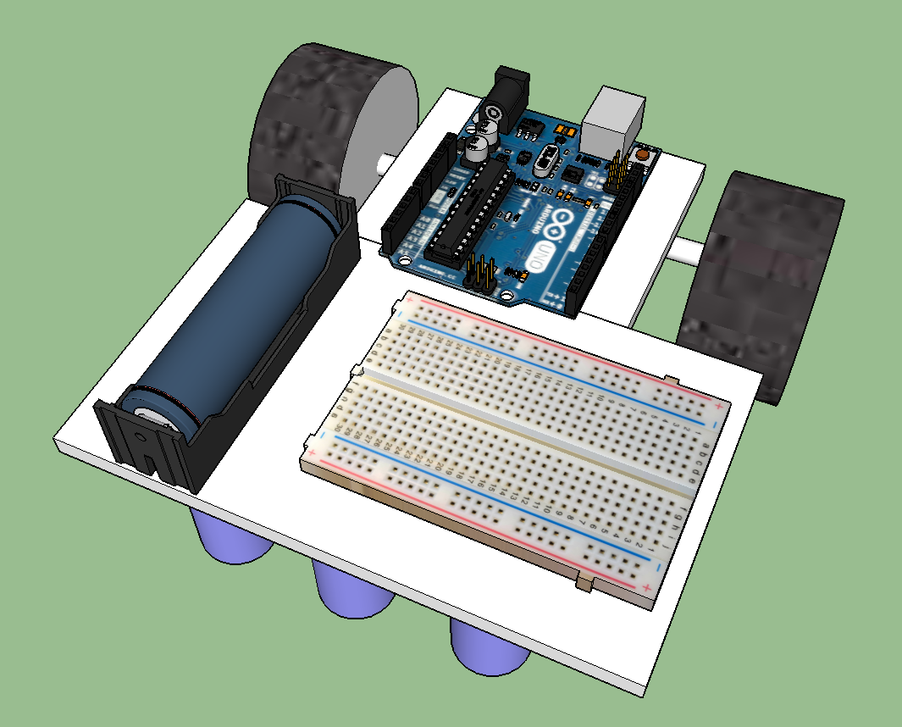

**Master Schedule**

***Team Function:*** To build a self-driving car that can go through a map/maze

|  |  |
| --- | --- |
| **Group Members** | **Roles / Assignments / Jobs** |
| Braulio | Project Manager |
| Mohammad-Ali | Chief Programmer |
| Matthew | Chief Engineer |

***Expected Begin Date: 22 Nov 2018 Expected End Date: 15 Jan 2019***

|  |
| --- |
| **Materials Needed** |
| 1 Arduino |
| 2. Breadboard |
| 3. Wheels |
| 4. Caster |
| 5. White led(s) and LDR(s) |
| 6. Motor Driver IC |
| 7. Resistors |
| 8. Gearbox with drive motors (and wheels) |
| 9. Wires |
| 10.Glue and tape |
| 11.Batteries |
| **Things To Be bought** |
| 1. Additional LEDs and LDRs |
| 2. Battery holder and a battery |
| 3. Co-Polyester Filament |

**GANTT Chart**

|  |  |  |  |  |  |  |  |  |  |  |  |  |  |  |  |  |  |  |  |  |  |  |
| --- | --- | --- | --- | --- | --- | --- | --- | --- | --- | --- | --- | --- | --- | --- | --- | --- | --- | --- | --- | --- | --- | --- |
| **Time (2018/19)** | | | | | | | | | | | | | | | | | | | | | | |
| **Tasks** | **22 – 23 Nov** | | | **26 – 30 Nov** | | | **3 – 7 Dec** | | | **10 – 14 Dec** | | | **17– 21 Dec** | | | **24-4**  **Dec/Jan** | **7 – 11 Jan** | | | **14 – 18 Jan** | | |
| Master Schedule |  | | |  | | |  | | |  | | |  | | |  |  | | |  | | |
| Chart Completion |  | | |  | | |  | | |  | | |  | | |  |  | | |  | | |
| Plan Report |  | | |  | | |  | | |  | | |  | | |  |  | | |  | | |
| Create a Sketchup Model |  | | |  | | |  | | |  | | |  | | |  |  | | |  | | |
| Build chassis |  | | |  | | |  | | |  | | |  | | |  |  | | |  | | |
| Create a Sample circuit |  | | |  | | |  | | |  | | |  | | |  |  | | |  | | |
| Fabricate Drive Train |  | | |  | | |  | | |  | | |  | | |  |  | | |  | | |
| Write Code |  | | |  | | |  | | |  | | |  | | |  |  | | |  | | |
| Integrate Electronics With Robot |  | | |  | | |  | | |  | | |  | | |  |  | | |  | | |
| Build a Maze |  | | |  | | |  | | |  | | |  | | |  |  | | |  | | |
| Test and Refine Robot |  | | |  | | |  | | |  | | |  | | |  |  | | |  | | |
| Have Robot Graded |  | | |  | | |  | | |  | | |  | | |  |  | | |  | | |
| Final Report |  | | |  | | |  | | |  | | |  | | |  |  | | |  | | |
| Case |  | | |  | | |  | | |  | | |  | | |  |  | | |  | | |

**Planning Organizer**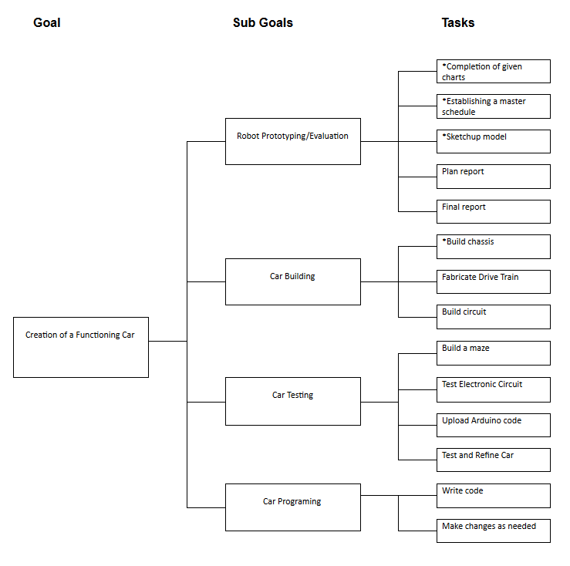

**PERT Charts**

#### 

**Evaluation**

Going into this project, we had two straight forward expectations for our car. The first was to build the car so that it successfully follows the line, and the second was to construct a clean, organized, and visually appealing car both on the inside of the case and out. Our first expectation was quite simple, and we managed to achieve it and executed it effectively. Our code is as perfect as we could get it, yet it is sufficiently functional to get the car to navigate the maze and return to its starting location. The LDRs are well positioned for the car to be able to make constant adjustments along its route, and the weighting added to the exterior case enables good tire traction. Our second expectation was a more general one, as we were just striving for a neat, well-constructed car. Our circuitry is well organized, with no stray wires. The interior design is laid out nicely, making room for all the components and creating a balanced weight across the base. We also created a nice 3D printed outer casing, giving our car a clean look on the exterior. In the end, we were able to happily meet our expectations of not only a functional car but a clean looking one as well.

To improve upon the project, if were we to do it again, we would first build the car so that the LDRs are positioned closer to one another. We originally built them with too much space in between, and it was only until well after the base was fully constructed that we decided to reposition the LDRs. We had to rebuild the paper casing for them at an angle, directing them more to the center to reduce the distance between them so it would move better and more in a straight line. We were able to execute this change effectively, but it would've been easier to avoid that step altogether by positioning them closer from the start. Secondly, we would plan our code better. It did end up working well in the end, but getting to that point was a long process of trial and error, with constant adjustments and additions. If we had planned how we wanted the code to run before diving right into writing it, it wouldn't have taken as long as it did to get to the point where we were happy with it. Our writing process consisted of just adjusting the code on the fly, which was more difficult than had we planned it better from the beginning. Obviously, the code would require constant adjustments no matter what, but starting off with a clearer picture of how we wanted it to run would've made for quicker adjustments and revisions. Thirdly, we would colour code the wires better. The wires themselves were well organized, but we did not have a consistent pattern of colours. This made things unnecessarily difficult as more and more wires were added onto the breadboard. When wires would accidentally detach, it took longer than it needed to figure out where they went. Lastly, we would have put all of our files onto the cloud to begin with that way in case any member was away, a computer broke down, or we forgot we needed it we would be one click away from it. This would have saved us time since we wouldn't have to start a new piece of code.